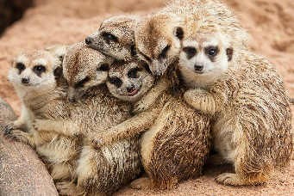

**Year 1 Learning Leaflet**

**Paws, Claws and Whiskers 2025**

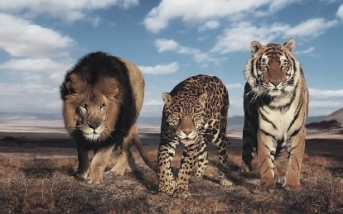

Spring 1

Year 1

Why don’t meerkats live in Silsden?

Starting off the new year, we will be looking at all thing’s animals. We will explore a range of animals, developing our understanding of places around the world and creating some animal artwork.

Key Dates

Tiger who came to tea party –

Mon 13th Jan 2:15pm

Animals UK Visitor – Wed 15th Jan

Y1 Planetarium Visitor – Wed 6th Feb

Final opportunity to bring in Home Learning – Mon 10th Feb

Topic showcase – Thurs 13th Feb (TBC)

End of term – Thurs 13th Feb



PSHE/RE/Music

PSHE – All our PSHE learning this half-term will be around the theme ‘Keeping Myself Safe’.

RE – All of the RE learning this half-term will be around the theme: A Good Life - How can we make good choices?

Maths

This half-term in Maths we will be focusing on numbers within 20. The children will be looking at the place value of these numbers and later apply their knowledge of these numbers when adding and subtracting.

We will be continuing to promote the use of Numbots to support children in securing their basic mathematical skills. The children’s achievements in upgrading Rusty will continue to be celebrated.



Reading/Phonics

This half-term we will continue to develop a love of reading. We will also continue to build our phonetic knowledge through our daily phonics sessions and develop our blending skills to read both real and alien words.

Topic

Art and Design – Create a range of animal artwork using different skills and materials.

Geography – Explore the 7 continents and develop an understanding of the equator. To notice geographical similarities and differences between Silsden and the Kalahari Desert.

**Key Vocabulary -** Africa, Antarctica, Asia, Australia, Europe, Geography, Human Features, North America, Physical Features, South America

Outdoor PE – Developing our spatial awareness and agility skills.

Indoor PE – To continue practising traversing and understanding safety around the climbing wall.

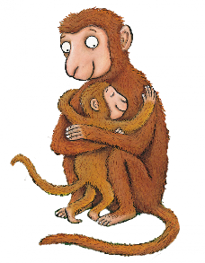



Writing

This half-term in English we will be exploring the texts The Tiger Who Came to Tea by Judith Kerr and Monkey Puzzle by Julia Donaldson. We will continue to use ‘think it, say it, write it, check it’ to write sentences that have capital letters, full stops, finger spaces, phonics for spelling and challenge ourselves to use adjectives to describe. We will then introduce the suffixes ‘er’ and ‘ed’.

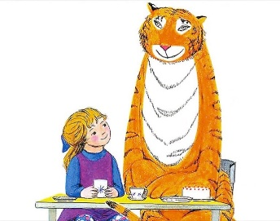

Science

This half-term in Science we will be focusing on the topic ‘Animals, including humans’. The children will be conducting research into a range of common and exotic animals, identifying, classifying and grouping them, noticing some similarities and differences.